**Drop Required User DB’s – (3) -- SQL Server.**

--Below TSQL Script will kill all DB connections and delete all databases in the list.

**--Ensure that before Dropping any DB, please take a Full DB Backup for safer side.**

**--Before dropping the below mentioned user databases.**

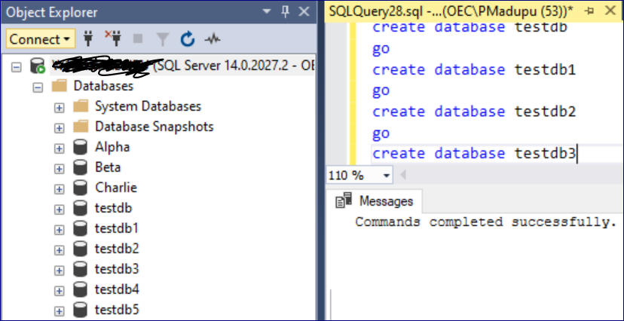

**Case-1: Below TSQL Script will drop all User DB’s except System DB’s, Alpha, Beta, Charlie.**

use master

go

declare @dbnames nvarchar(max)

declare @statement nvarchar(max)

set @dbnames = ''

set @statement = ''

select @dbnames = @dbnames + ',[' + name + ']' from sys.databases

where name

NOT IN ('master','model','msdb','tempdb') -- System Databases to keep

AND name NOT LIKE '%Alpha%' -- Database to keep

AND name NOT LIKE '%Beta%' -- Database to keep

AND name NOT LIKE '%Charlie%' -- Database to keep

if len(@dbnames) = 0

begin

print 'No Databases to Drop'

end

else

begin

set @statement = 'Drop Database ' + substring(@dbnames, 2, len(@dbnames))

print @statement

exec sp_executesql @statement

end

go

**--After dropping the user databases which are not mentioned in above TSQL Script (Means not needed any more).**

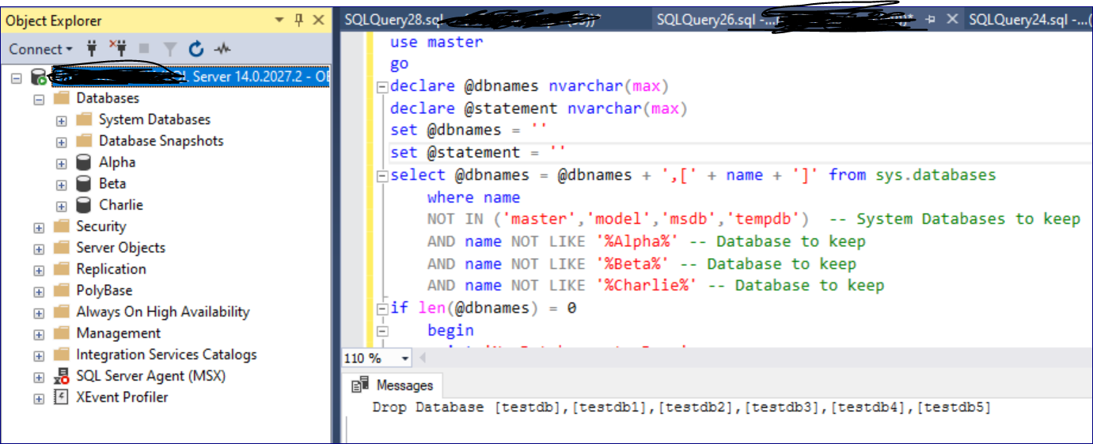

**Case-2: Below TSQL Script will drop only mentioned User DB’s.**

**--Before dropping the mentioned user databases.**



use master

go

declare @dbnames nvarchar(max)

declare @statement nvarchar(max)

set @dbnames = ''

set @statement = ''

select @dbnames = @dbnames + ',[' + name + ']' from sys.databases

where name IN ('testdb','testdb1','testdb2','testdb3','testdb4', 'testdb5') -- System Databases to keep

if len(@dbnames) = 0

begin

print 'No Databases to Drop'

end

else

begin

set @statement = 'Drop Database ' + substring(@dbnames, 2, len(@dbnames))

print @statement

exec sp_executesql @statement

end

go

**--After dropping the mentioned user databases.**

